Match the photo to the correct name.

1. 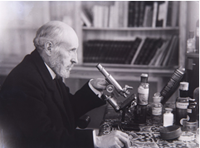 Scientist
2. Don Santiago Ramón y Cajal
3. Odón de Buen y del Cos
4. Antonio Arnaiz-Villena
5. Luis García Sáinz

Answer: a

1. 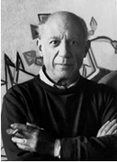 Artist
2. Antonio Gisbert Pérez
3. Raimundo de Madrazo y Garreta
4. Pablo Picasso
5. Francisco Pradilla Ortiz

Answer: c

1. 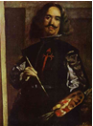 Painter
2. Joan Miró
3. José Caballero
4. Ramón Castellano de Torres
5. Diego Velázquez

Answer: d

1. 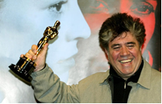 Film director
2. Jaime de Armiñán
3. Alfonso Balcázar
4. Pedro Almodóvar
5. Sadrac González

Answer: c

1. 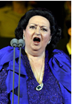Soprano
2. Montserrat Caballé
3. Marta Almajano
4. Ainhoa Arteta
5. Noemí Carrión

Answer: a